Adding keyboard file
Click Add New button.
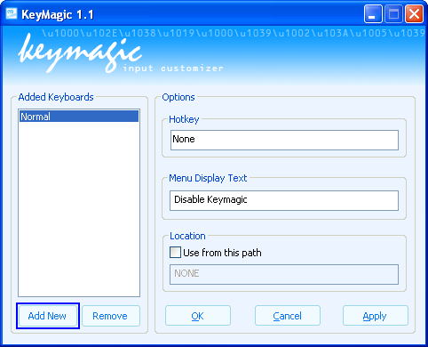
Figure 1

Select the keyboard file and click open.
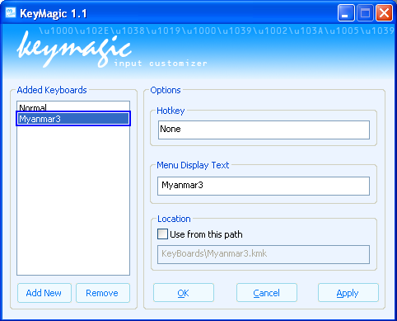
Figure 2

If you see keyboard name in the list, it's ready to use. (You will need to restart the application which you want to use together with Keymagic).
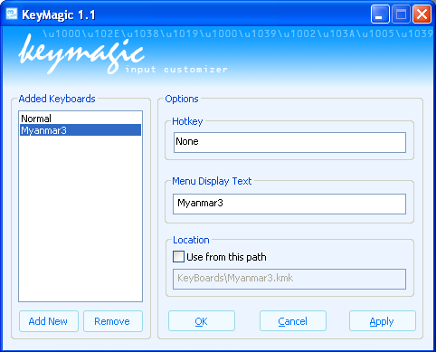
Figure 3

Adding keyboard file from explorer

Explore the path where keyboard file located.
Right click on the keyboard file.

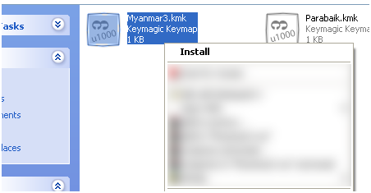
Figure 4

Select Install.
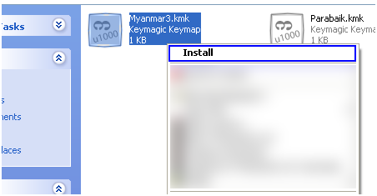
Figure 5

(Note: Myanmar Keyboard files are located in {INSTALLDIR}\Keyboards; you will need to add keyboard file yourself by one of the above method)

Removing keyboard file

Select the keyboard name that you want to remove.
Figure 6
Click Remove button.

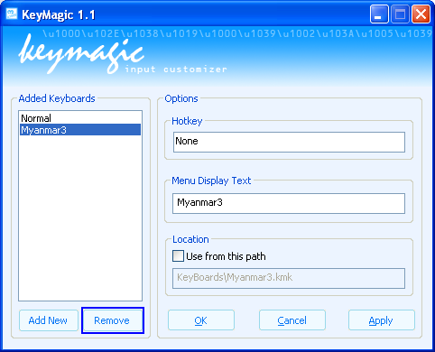
Figure 7
Click Apply button.

Setting UP A hotkey For A Keyboard

Select a keyboard name that you want to set hotkey.
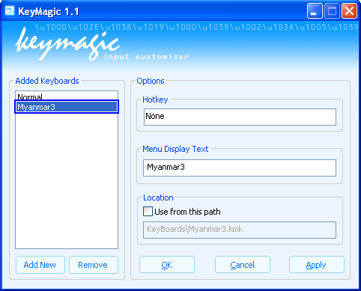
Figure 8

Click on the Hotkey box and press keys that you want to set as hotkey.
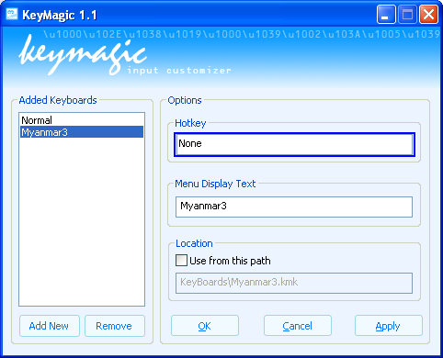
Figure 9

Click Apply button.
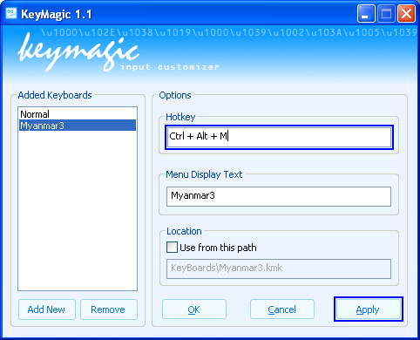
Figure 10

Using Keyboard From Custom PATH
Check Use from this path.
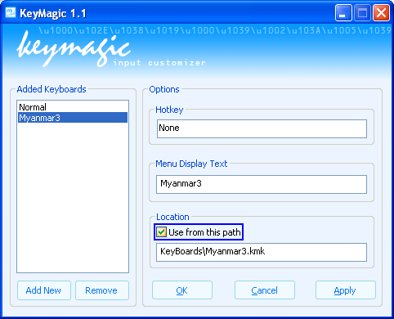
Figure 11
Provide a full path to a keyboard file.
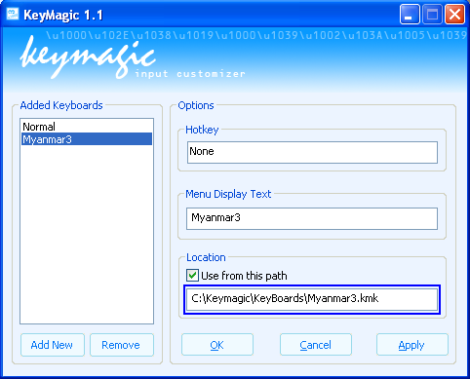
Figure 12
Click Apply button.

Selecting keyboard from the Tray Icon

Left Click on the Keymagic tray.
Figure 13
Select a keyboard file, you want to use.
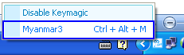
Figure 14

Closing Keymagic
Right Click on the Keymagic tray and click Exit.
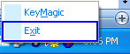
Figure 15

Syntax Used in Keymap scripting

\\
Use to represent \.

\(Decimal Value)
Use to represent a character decimal value.
(e.g. \65 = 0x41 = A)
\065, \0100 (Don’t put zero)

//(Comment String)
Use to represent Comment.

FAQ:

Q: I cannot add or remove the keyboard file in Windows Vista. How can I do?
A: It is because UAC (User Account Control) blocking Keymagic’s operations. Please run Keymagic as an Administrator privilege or turn off UAC.

